# Evidence of ash from Australian Forest fires observed in Auckland, New Zealand

## Introduction

Bushfires in Australia are a natural hazard occurring on a regular basis (<http://www.ga.gov.au/hazards/bushfire.html>). In south eastern Australia the bushfire season peaks in summertime. They release tremendous amounts of particles into the atmosphere. These particles impact the air quality not only on a local scale. Pyroconvection takes place over large fires emitting a large amount of heat and thus buoyancy to lift the ash particles above the boundary layer (Freitas et al., 2006). Once decoupled from the atmospheric boundary layer the particle deposition is reduced and the transport is more efficient due to less turbulence and higher wind speeds in the free troposphere compared to the atmospheric boundary layer (de Laat et al., 2012). In case of south eastern Australia with its prevailing west winds the particles reach the Tasman Sea. Since the marine boundary layer is shallow, the particles are transported in altitudes which are in the vertical range of ground based remote sensing instruments such as ceilometers.

Observations of an ash plume from Australian bush fires are described in

In the first half of January 2013 a number of bush fires burned in Australia: mainly in New South Wales and Tasmania, but also some in Queensland and Western Australia. (Maybe a bit more precise: how many fires or how many hectares have been burned and when exactly).

The fires were associated with a heat wave occurring at the beginning of the year together with a dry period and strong winds. (ref) Figure 1 is a MODIS picture of the day (see http://earthobservatory.nasa.gov/NaturalHazards/view.php?id=80127). It clearly shows three big fires with ash plumes.

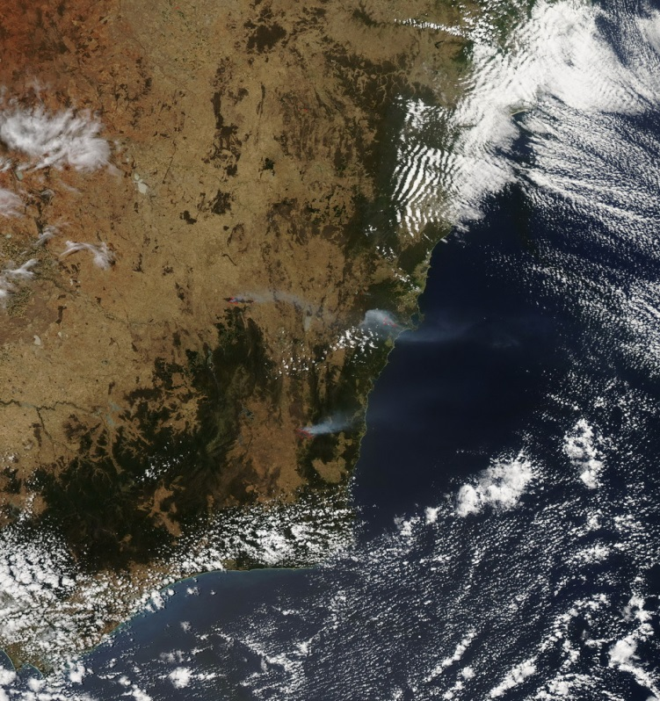

Figure 1: MODIS picture of the day showing three big Australian bush fires on 9 Jan 2013.

## Instruments

### Ceilometer

The University of Auckland operates a Vaisala CL31 ceilometer since August 2012. This ceilometer is a commercial eye-safe single lens lidar. The ceilometer is equipped with an InGaAs/MOCVD (Indium Gallium Arsenide/Metal-Organic Chemical Vapor Deposition) pulsed diode laser emitting at 905 nm with a pulse energy of 1.2µJ. The outgoing laser beam is collimated by the centre part of the lens and the incoming light is focused with the outer part of the lens onto the receiver. This design gives low nominal overlap heights of 10 m. In practice the signal above 50 m is used for the analysis. The vertical resolution in this study is set to 5m, which allows for an altitude range up to 3800 m. Further technical details of the ceilometer are described in Münkel et al. (2007) and Vaisalas User Guide (2009).

### Hysplit

The Hysplil model (Draxeler and Rolph, 2013) is used to calculate backward as well as forward trajectories to investigate the origin of the air mass observed in Auckland. In addition, dispersion modelling is also applied as another tool to assess the direction of movement of the ash plume.

### Calipso

## Methods

Evidence of ash is observed over New Zealand on two different occasions. Ceilometer data by itself cannot unambiguously detect ash. Hysplit data as well as Calipso data are used to support the finding. Unfortunately, no other ground based remote sensing instruments, such as sun photometers or research lidars, are available in Auckland to confirm the results obtained with the ceilometer. In addition, photographs taken from the Auckland North Shore can help to visually separating ash from cloud.

Ash detection with the ceilometer is based on the magnitude of the backscatter signal. Photographs taken by a digital camera situated on the North Shore have been compared to the ceilometer signals. It could be concluded that clouds occur for backscatter signal greater than 500 a.u. The background signal of the free atmosphere is below 100 a.u. If the ceilometer signal is between 100 and 500 a.u. and the photographs do not show any clouds it is assumed that aerosols are detected.

To further support the suspected ash the origin of the airmass is determined by the Hysplit trajectory model in backward and forward direction. Further the dispersion of the modelled plume was modelled with Hysplit to determine its spatial distribution from the source region.

To further underline the ash detection with a ceilometer Calipso data was evaluated in case overpasses have been available.

## January 2013

On 13th of January a backscatter signal between 50 and 400 b.u. has been observed above 2000 m altitude between 18:00 and 21:00 NZST, see time height sections in Figure 2. The signal is too low for clouds (clouds usually lead to a backscatter signal of >500), so it should be due to particles. On the majority of days only noise or a signal below 50 b.u. is observed in this height. The high backscatter values above 1000 m around midday are an instrumental feature and thought to be due to internal reflections. Therefore we are not able to observe ash around noon because the low particle signal is masked by instrumental noise.

Figure 3 shows the backscatter profiles between 18:00 and 21:00 NZST every half hour. The high backscatter signal between 750 m and 1600 m is due to clouds. This is confirmed by photographs. The insert in Figure 3 shows the backscatter signal up to 500 bu between 1600 m and 3800 m. At 18:00 the backscatter signal is largest with values up to 420 bu. Between 18:30 and 20:30 the ash cloud remains over Auckland with backscatter values around 120. At 21:00 NZST the backscatter values return to normal background values below 50.

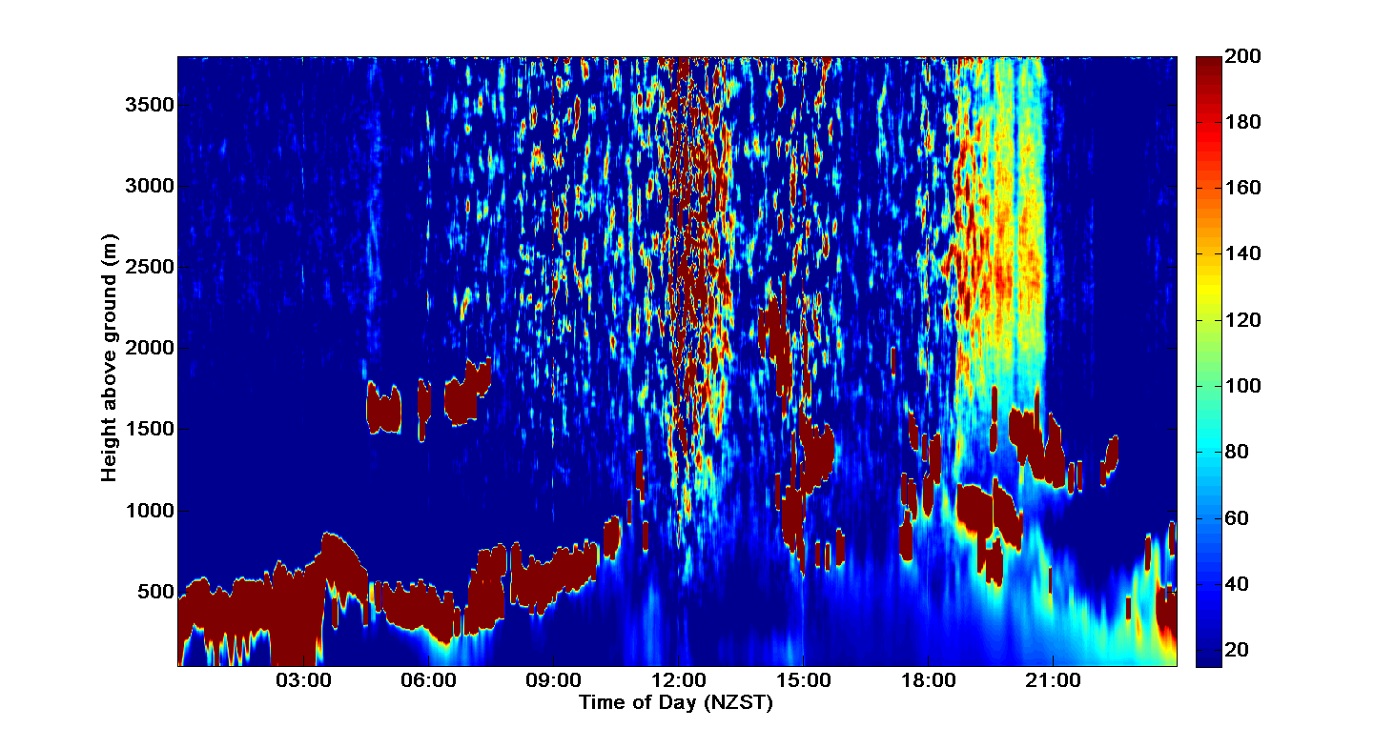

Figure 2: The signal above 2000 m between 18:00 and21:00 could be ash from Australian fires.

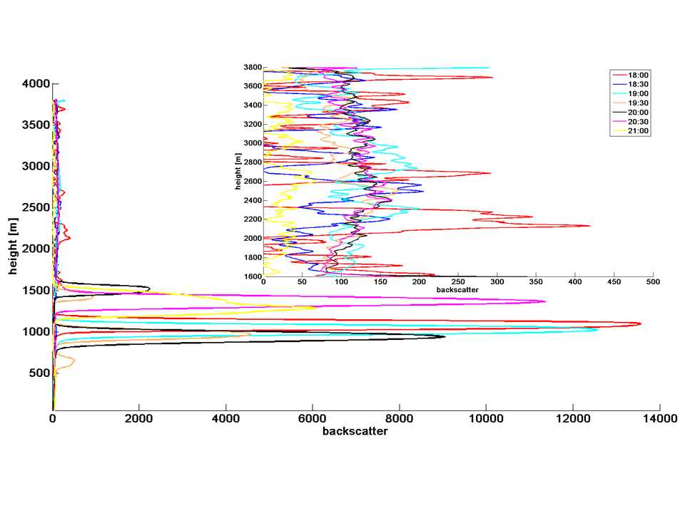

Figure 3: Profiles of backscatter signal on January 13th, 2013 between 18:00 and 21:00 NZST. The insert shows the backscatter signal up to 500 bu in a height range from 1600 m to 3800 m.

## Hysplit trajectories

To investigate whether the source region of the airmass over Auckland on 13 January 2013 originated over Australia, back trajectories have been calculated with Hysplit (Draxler and Rolph, 2013).

It was also tested if forward trajectories originating over New South Wales at the locations of the fires crossed the Tasman Sea and arrived over Auckland.

### Backward trajectories

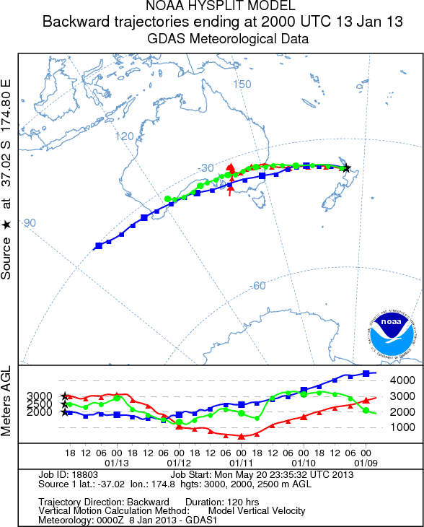

Figure 4: Back trajectories starting in Auckland on 13 January 2013 on 20:00 UTC. All trajectories went across the region of the fires.

On 13 January 2013 backward trajectories were started in Auckland at 20:00 UTC (see Figure 4). The trajectories went directly across the region of fires around 00:00 UTC on 12 January 2013. At this point in time the air was at an altitude between 1000 and 2000 m.

### Forward trajectories

There is also evidence in the forward trajectories originating at the location of the fires that air masses move across the Tasman Sea towards Auckland. One example is the forward trajectory shown in Figure 5. It was started on 11 January 2013, 23:00 UTC. The trajectory started in 2000 m went over Auckland where it arrived in an altitude of around 2500 m approximately at 18:00 UTC on 13 January 2013.

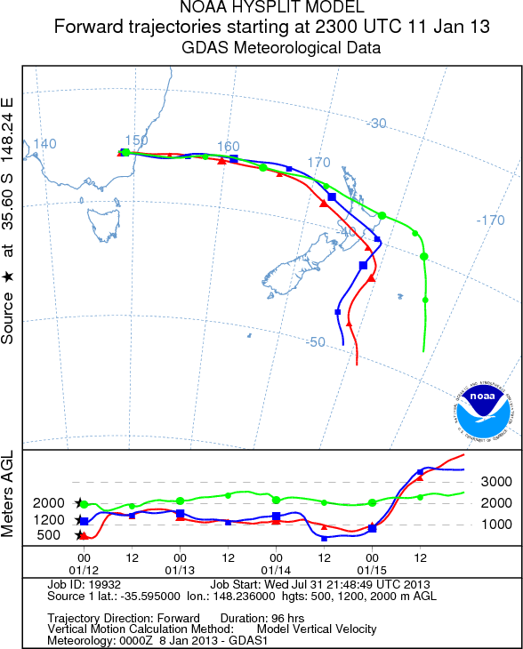

Figure 5: Forward trajectories started at the location of a fire in New South Wales. The air in 2000 m arrived in Auckland in around 2500 m in the afternoon/early evening.

## Dispersion Modelling with Hysplit

From Figure 5 we learned that the ash observed in Auckland came with the air 2000 m above the fire. Did the ash disperse this high up into the atmosphere? To answer this question Hysplit Dispersion modelling was performed for the starting time of the forward trajectories. Figure 6 shows two different particle distributions. On the left side the particle distribution on 5:00 UTC, on the right side on 23:00 UTC is shown, both on 12 Jan 2012. These particles have been released at 23:00 UTC on 11 January 2013. The particles moved westwards. The particles reached an altitude up to 6000 m (see lower panel on the right side). On the distribution on 5:00 UTC they reach an altitude of up to 3000 m at the point of origin.

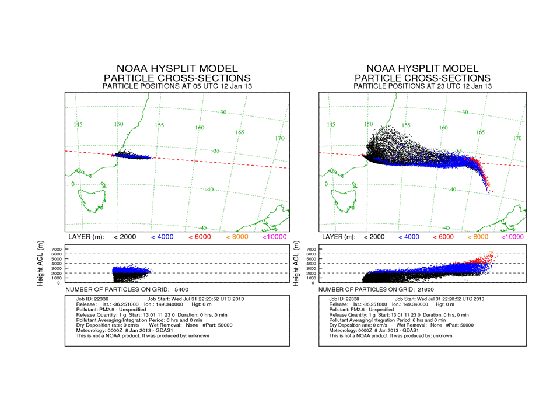

Figure 6: Particle distribution at 5:00 UTC (left) and 23:00 UTC (right) on 12 Jan 2013. The particles have been released at 23:00 UTC on 11 Jan 2013.

The particle concentration on 12 January 2013, 23:00 UTC is shown in Figure 7. The particles have also been released at 23:00 UTC on 11 January 2013. The concentration is averaged between 0 and 2500 m.

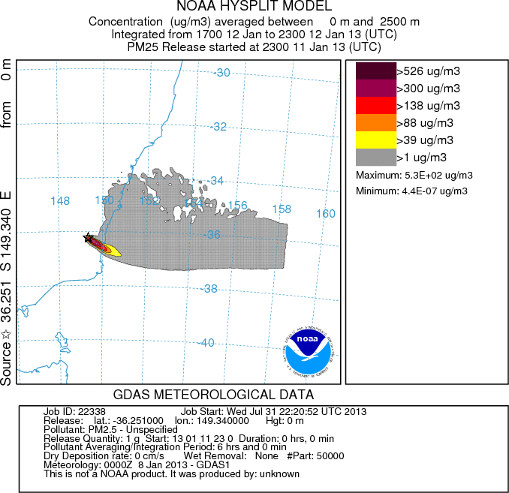

Figure 7: Particle concentration integrated between 17:00 and 23:00 UTC, 12 Jan 2013, for particles released from the NSW bush fires on 11 Jan 2013 on 23:00 UTC.

# Calipso

Data from Calipso (http://www-calipso.larc.nasa.gov/products/lidar/browse_images/show_date.php?s=expedited&v=V3-02&browse_date=2013-01-12) showed evidence of aerosol over the Tasman Sea west of New Zealand as well. Figure 8 shows the Vertical Feature Mask of the Calipso path on 12 Jan 2013 around 2:40 UTC. Between 37°S and 30°S Calipso observed aerosol between 1000 and 3000 m.

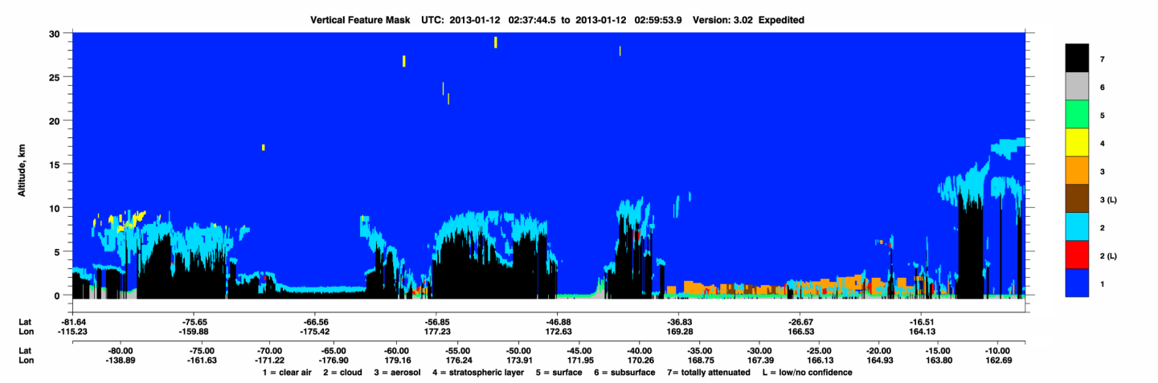

Figure 7: Vertical Feature Mask from Calipso for 12 Jan 2013 between 2:37 and 3:00 UTC. In the region of interest around 35°S aerosol is observed.

# October 2013

In October 2013 we have two incidences where we observed ash over Auckland originating from the spring fires in Australia.

The profiles of the ceilometers show

# Discussion/ Open questions

Why is 13 Jan 2013 between 18:00 and 21:00 NZST the only period where we actually see evidence of ash with the ceilometer? Hysplit suggests that ash should/could be observed at other times.

The hysplit results are consistent with each other. If I start with the backward trajectories and find that the air came from the region of the fires, I can look up an exact time and location in Hysplit text result file. I can use this time and location and model forward trajectories, and they reach Auckland. Then, when I do the dispersion modelling it is the same, the particle plume basically extends itself along the path of the forward trajectories.

At the time when we observe the ash there is not really evidence in Hysplit that the air masses originated over New South Wales. Unfortunately the time 20:00 UTC (indicated in Hysplit) is not 20:00 NZST when we observed the ash with the Ceilometer. The backward trajectories started in Auckland at 20:00 NZST (about 8:00 UTC) do not all cross the fire region. There is only one originating in New South Wales or Queensland is the 3000 m one. See following picture:

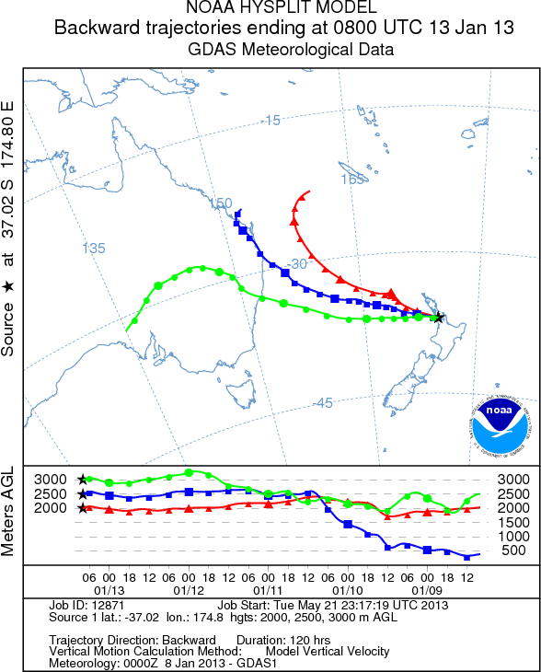

## Dispersion Modelling

In Figure 6 we see the particle concentration averaged between 0 and 2500 m. This particle concentration is quite low. It would better to average the particle concentration between 2000 and 3000 m because this is the altitude range of interest for our study. In addition, Figure 5, right panel, shows the particle distribution. There are no particles in at least the lowest 1000 m further away from the point of origin. But I don’t know whether I can set a lower boundary for the particle averaging, I know I can set an upper boundary.

## Calipso

The time of the overpass of Calipso is before we observed the ash over Auckland with our ceilometer. Calipso observed aerosol at the same time at the same location as we would expect the ash to be from the Hysplit modelling (trajectory as well as dispersion).

# Conclusion

Calipso and Hysplit data both show evidence that the Australian Ash reached Auckland. The ceilometer shows evidence as well, but only during one evening. The times of ash observed by the ceilometer are only partly coinciding with Hysplit.

## References

Draxler, R.R. and Rolph, G.D., 2013. HYSPLIT (HYbrid Single-Particle Lagrangian Integrated Trajectory) Model access via NOAA ARL READY Website (http://www.arl.noaa.gov/HYSPLIT.php). NOAA Air Resources Laboratory, College Park, MD.

Freitas S.R., K. M. Longo, and M. O. Andreae (2006). Impact of including the plume rise of vegetation fires in numerical simulations of associated atmospheric pollutants Geophys. Res. Lett., 33, L17808, doi:10.1029/2006GL026608.

Münkel, C., Eresmaa, N., Räsänen, J., Karppinen, A., 2007. Retrieval of mixing height and dust concentration with lidar ceilometer. Boundary-Layer Meteorology, 124, 117–128.